COSHH ASSESSMENT
NCS/FM/070 Issue005/Jul09

Ref: COSHH 08

Assessed by: Matt Traynor Position: Managing Director

Date: January 2022

Reviewed by: Matt Traynor
Position: Managing Director
Date: January 2022
Issue: 008/January 22

Trade name / Supplier: Telephone number:

Contact:

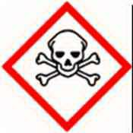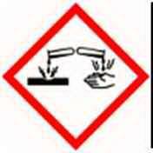Toxic Corrosive

Product type:

Handling of Cement

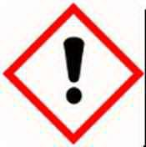Irritant

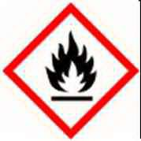Highly
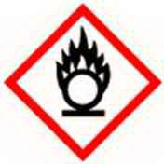Flammable

Chemicals and appearances:

Odorless fine white to grey powder

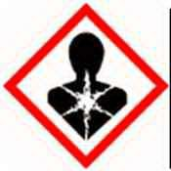Harmful
Oxidising

Risk associated with use: | Cement dust acts as a skin and respiratory irritant. Dust and wet cement act as a serious irritant
Personal Protection: | Dust proof goggles should be worn, whenever there is a risk of wet mix entering the eyes. Protective clothing should be worn, including waterproof gloves, trousers and appropriate footwear
Storage:  Store in dry conditi | ons, preferably above ground on pallets protected by shrink wrapping - this will prevent moisture ingress and prolong shelf life
Disposal: | Dispose of empty bags or material at an authorised disposal site
Fire: | Not flammable

Appointment Effect First Aid

Dermatitis, irritation, redness, pain
Skin
Wash well with plenty of soap and water for at least 15 minutes
Remove contaminated clothing. Seek medical advice. Wash clothing before re-use

Irritation, stinging Flush eyes with copious quantity of water.
Eyes
If irritation persists, seek medical advice

Inhalation Irritation to nose and throat. Move to fresh air and rest. If symptoms persist seek medical advice

Nausea, Do not Induce vomiting. Wash out mouth with water. Seek medical advice if deemed necessary
Swallowing

